Language focus 4 (p123-128)
*I, Mục đích yêu cầu: Sau giờ học,
- Học sinh ôn tập và thực hành Past simple , Indefinite quantifiers , Too and Either , So and Neither và Imperatives .
* II, Kĩ năng luyện tập:
- Luyên bài tập ngữ pháp .
*III, Kiến thức cần đạt được:
+ Học sinh trung bình: - Học sinh ôn tập và làm bài tập phần Language focus .
+ Học sinh khá, giỏi: - Làm thêm bài tập giáo viên tự soạn cho phù hợp và giao cho học sinh .
* Ngôn ngữ cơ bản:
- Từ mới: mango; corn; peel; slice; vinegar; mixture; serve; ..
- Cấu trúc câu: Ôn tập Past simple và Imperatives .
- Indefinite quantifiers : A little / a lot of / lots of / too much.
- Too / either / neither / so.
IV, Procedure:

A. khởi động : Use the correct verbs form ( các em viết dạng đúng của thì với động từ trong ngoặc )
1. Yesterday , Hoa and her aunt ( go ) .............. to the market. ( go → went )
2. I would like ( tell ) ............ you about my family .
( would you like + to Verb . . . . . ? )
3. My father ( not watch ) ............. TV last night . He ( read ) . . .. . . . newspapers and magazines. ( didn’t watch/ read )
4. When . . . . you ( buy ) ............. this dress ? two days ago .
* lưu ý: dấu hiệu nhận biết thầy đã gạch chân là thì quá khứ )
B. New lesson: ( bài mới )
1. Simple past tense: ( thì quá khứ )
Cấu trúc thì quá khứ: (+ ) S + V-ed/ V2
(-) S + didn’t + V1
(?) Did + S + V1? – yes, S + did.
- No, S + didn’t.
a. Language focus 1 ) Simple past tense (p.123 – 124)
- Ss do the exercise in individual.
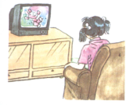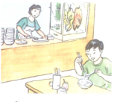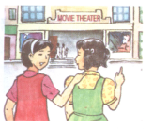

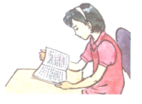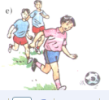
b. Mapped dialogue: T uses the pictures p. 123( các em xem các hình trang 123, và hướng dẫn trả lời theo sơ đồ. )

Did you do homework ? No, I didn’t. I watch T.V

Eat dinner at home ? No, I didn’t. I had a restaurant.

Go to School yesterday ? No, I went to the movies theater.

Watch video weekend ? No, I didn’t. I read books.

Play Baseball yesterday ? No, I didn’t. I played soccer.
* Example exchanges : ( 1 số vi dụ tham khảo, em làm và viết vào tập nhé.)
S1 : Did you do your homework yesterday ?
S2 : No, I didn’t. I watched T.V
S1 : Did you have dinner at home ?
S2 : No, . . . .
S1 : Did you go to school yesterday ?
S2 : No, . . . . .
S1 : Did you watch video at weekend ?
S2 : No, . . . .
S1 : Did you play baseball yesterday ?
S2 : No, . . . . .
2. Indefinite quantifiers: (p.124 – 125) ( định lượng không xác định )
A little: 1 chút
A lot of/ lots of: nhiều
Too much: quá nhiều
a. Matching: Write the correct expression
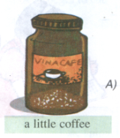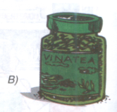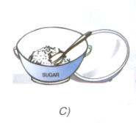
A lot of tea a little sugar
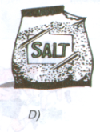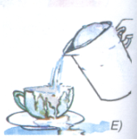
A lot of salt too much water
b. Gap fill: Complete the dialogues. ( các em hoàn thành bài tập, ghi nhận vào vở )
Ex: Nga: What’s the matter, Hoa?
Hoa: I feel sick. I ate too much candy.

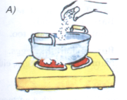
Mrs. Quyen: Lan, add some salt to the vegetables, please.
Lan: . . . . or a lot?
Mrs. Quyen: Only . . . . . . . I think. ( a little )

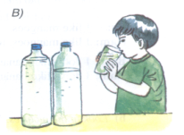
Dr.Le : You must drink . . . . water every day. ( a lot of
Ba : Yes, doctor.

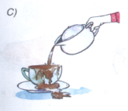

Mr. Nhat : Stop, please. That is . . . coffee. (too much
Waitress : I’m sorry, sir. I’ll clean the table for you.

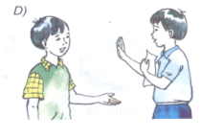

Minh : Can you give me some paper, Nam?
Nam : I’m sorry. I only have a little and I need it.

3. Too. Either / so, neither: Language focus 4 (p.126 and 127).
a. Language focus (p.126): too and either
- Ask students to work in pairs to read the dialogues.
- Ask students to look at the picture and make up similar dialogues (pairworks): the symbol check (✓) used for like, symbol (✗) used for don’t like.
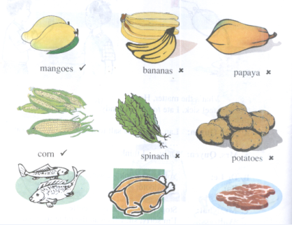
1, Nam: I like mangoes. Ba: I do, too.
2, Nam: I don’t like bananas. Ba: I don’t either.
3, Nam: I don’t like papaya. Ba: I . . . . .
4, Nam: I like corn. Ba: I . . . . .
5, nam: I don’t like spinach. Ba: I . . . .
6, Nam: I don’t like potatoes. Ba: I . . . .
7, Nam: I like fish. Ba: I . . . . .
8, Nam: I don’t like chicken. Ba: I . . .
9, Nam: I like beef. Ba: I . . . .
b. Language foucus 4 (p.127): So and Neither
- Ask students to read the examples in the book (p.127).
- Ask students to look at the picture above to make up 8 dialogues with So and Neither.
Ex: Nam: I like mangoes. Ba: so do I.
Nam: I don’t like bananas. Ba: Neither do I.
3, Nam: I don’t like papaya. Ba: . . . . . . do I.
4, Nam: I like corn. Ba: . . . . . . . do I .
( còn 5 hình trang 126, các em làm vào vở BT nhé )
4. Imperatives: Language focus 5 – p. 127 – 128:
* Gap fill: Complete the instructions:
Ask students to look at the pictures and the words in the box to complete the instructions:
Add ( thêm vào) mix ( trộn ) peel ( gọt ) slice ( lát)
stir ( khấy ) wait ( đợi ) wash ( rửa )
Making cucumber salad
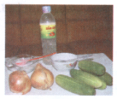
Ingredients: ( thành phần)
- 500 grams of cucumber.
- 2 onions.
- small cup of vinegar.( giấm
- one teaspoonful of salt ( 1 muỗng muối )
- five teaspoonfuls of sugar

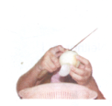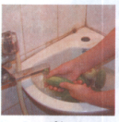
a) Peel the onions b) Wash the cucumbers and the onions

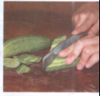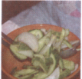
c) Slice the cucumbers and the onions d) Mix the slices

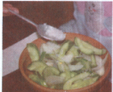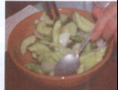
e) Add a little salt, sugar and vinegar to the mixture f) Stir the mixture.
g) Wait for five minutes and the salad is ready to serve.
C. Homework :
- Do all exercises in Language focus again.
- Prepare Lesson 1 (A1,) – Unit 13.

